

Electronic Engineering

Advanced Embedded System Lab

Summer Term 2023

Prof. Dr. Hayek Ali

Documentation for

Smart Gas Leakage System

Team F

Shihab Ud Doula

Neaz Mahmud

Yoonsuk Choi

**INTRODUCTION**

The term “smart devices” refers to devices we use every day that are connected to the Internet. They let us create smart homes and devices that can be managed and controlled remotely from anywhere we please. These IoT devices now have more potential to be implemented in every case which causes a threat to humanity as wireless networks have been integrated in a more complex yet standard form.

Gas leakage is a common phenomenon is many developing and underdeveloped countries where an ordinary person cannot often detect accumulated gas from leaks from pipelines or Cylinders. But it is they who pay the ultimate price. As we cannot see gas with our naked eye, we cannot detect where it has originated from resulting having casualties every year.

Focusing on such issues has resulted us to make “Smart Gas Leakage System” which is an excellent integration of hardware and software. This system has been created with advanced hardware and designed with rich software to serve its purpose to decrease gas leaks around the world.

**CONCEPT DIAGRAM**

Block Diagram:

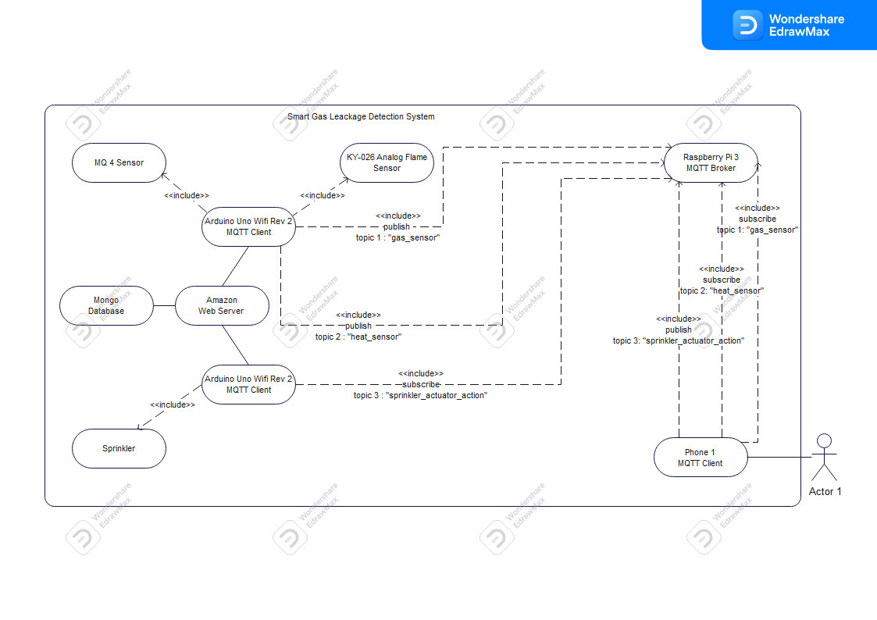

Project Description:

Our Smart Gas Leakage System makes use of a distributed system in which wireless sensor network (WSN) technologies are used to connect microprocessors and sensors/actuators. To be more precise, the environmental restrictions for a room are specified by our smart device so that we can handle data from gas sensors and flame sensors to monitor the degree of gas leakage and spot potential fires.

In our project, the Raspberry Pi 3 model will serve as the central communication unit while the Arduino Uno and sensors act as clients, using the server-client approach. This will enable a two-way connection between end users and the actual space. The system can then be controlled either independently or in dependence on the users by instructing the actuators to operate in the proper ways.

**Hardware and Software Components**

Hardware:

* Arduino Uno Wi-Fi Rev 2
* Raspberry Pi 3
* Sensors and Actuators
* MQ4 Methane Gas Detecting Sensor
* KY026 Analog Flame sensor
* KY019 5V Relay
* KY053 ADC
* DC motor (Simulation of Sprinkler)

Software:

* Arduino Uno IDE
* MQTT Mosquito
* Python Libraries for programming Raspberry Pi for MQTT

**PROJECT AND TEAM MANAGEMENT** **(Still To Write)**

The following project was based on the introduction of Iot and WSN in our first lecture where we first realized how intuitive it is to use them in a single device. We started with basic knowledge of the system architecture of an IOT device which simultaneously has wireless connection with the outer world. We had to get us familiar on the following content for the project:

* Introduction into Arduino UNO Wi-Fi (REV2)
* Introduction into Raspberry Pi
* Sensor Applications
* Introduction to MQTT
* Introduction to IoT Applications

After our approved concept draft, we divided our work equally where each of was responsible for both hardware and software application. Firstly, we separated our work by one working with the Arduino and sensors. And one working with MQTT connection establishment through raspberry pi.

Task of each member-

Shihab Ud Doula:

Yoonsuk Choi:

Neaz Mahmud:

**Technologies**

* Sensor and actuator Technologies:

The following sensors and actuator were used in the project from the Sensor-Set X40.

**MQ4 Methane Gas Detecting Sensor:** This sensor is a key element of the project as it does the job of detecting invisible methane gas. This can detect the presence of methane (CNG) gas at concentrations from 300 ppm to 10,000 ppm.

**Analog Flame sensor:** This sensor is used to detect the presence of flames or fire. It operates on the idea of spotting variations in the light spectrum generated by a flame. The sensor offers an analog output signal that may be used to gauge the flame's ferocity or closeness.

**DC Motor:** This was used to show the simulation of sparkling water in a confined room as our device will be used space.

**Relay 5V:** The 5V relay module can be used to control a load such as a lighting system, motor, or solenoid. It can also be used to switch AC or DC voltages. The maximum voltage and current that the 5V relay module can control is dependent on the specifications of the relay. This was used to control the high amount of electrical current from the dc motor.

**Analog To Digital Converter (ADC):** It is used to convert an analog signal such as voltage to a digital form so that it can be read and processed by a microcontroller. Most microcontrollers nowadays have built-in ADC converters. It is also possible to connect an external ADC converter to any type of microcontroller. This was used as we are using a motor to convert the analog value to digital value while writing the program.

* Communication Protocol: **(Still To Write)**
* Programming language: **(Still To Write)**

We used C++ and Python programming language to program the whole system for the project. All the sensors were integrate together after writing code for each sensors were written initially. A

**IMPLEMENTATION (Still to write)**

Use Case

Our “Smart Gas leakage system” was designed to adapt with any environment we programmed it to. For our project purpose, our device is considered inside a room where it is connected in such a way that the initial detection and source of fire can be detected with much accuracy.

A sample example is shown in the figure:

References

<https://solwit.com/en/posts/how-iot-is-changing-the-world-around-us-the-future-of-the-internet-of-things/>

https://www.researchgate.net/figure/IoT-Based-Fire-Alarm-System-6_fig2_366590302